**Accounting Principles Assignment #3**

**Assignment # 3 – due to May 28, 2024 (200 pts)**

|  |  |  |  |
| --- | --- | --- | --- |
| 2024 1Q | Goldman Sachs | JP Morgan | Morgan Stanely |
| Price(1st, January) | 388 | 172 | 93.90 |
| EPS | 11.58(Dilluted) | 4.44(Dilluted) | 2.02(Dilluted) |
| PER | 33 | 38.73 | 46 |
| Forward PER | 11.95 | 12.41 | 14.77 |
| PER(Averaged 10years) | 11.69 | 11.69 | 12.76 |
| ROE | 0.03 | 0.04 | 0.03 |
| Retained Earnings | 140,690 | 342,414 | 99,811 |
| Revenue(2023) | 8,516 | 49,552 | 4,948 |
| Market cap | 149.24B | 574.15B | 161.64B |

Goldman Sachs’s main revenues are global market division which manages a broad range of strategies include equity, fixed income and equities intermediation and financing. Morgan Stanley is also a leading global investment bank which makes money with institutional securities, wealth and invest management. JP Morgan is the largest U.S. Bank by assets who provides financial transactions processing and asset management.

We firstly search for PER and EPS and ROE of each companies 2024 10-Q. and 2023 data. In 1Q 2024, Goldman Sachs had EPS 11.58, which is written in Goldman Sachs templates , However by our research, they have two EPS which is earning per common share of 11.67(basics) and 11.58(diluted).Goldman Sachs Market Price per share is 388 in 2024 January 1st 388, By dividing Price to EPS, we find PER which is 33. However, the result of finding Goldman Sachs’s PER in web search usually formed. The first reason result is different is they use Forward EPS or Trailing EPS which is projecting future net income or using last 12 month’s income. Also we calculate ROE which is Net Earning/Total shareholder’s Equity = 3931 / 118546=0.03. Additionally, Goldman Sachs reported their ROE is 7.5%, we suspect that it is based on 2023 10-k report that can derive the numerical output(8516/116905=0.07)

In 1Q 2024, JP Morgan had EPS of 4.44(Diluted), Price of 172,ROE of 0.04(13419/300277). we could get EPS information. In 2024 Q1, EPS was $4.45(Basic) and $4.44(Diluted).It is almost same. In 2023, EPS was $4.11(Basic) and $4.10(Diluted). EPS in 2024 is much more than in 2023. EPS calculation is (Net income – Preferred stock dividends) / weighted-average common shares outstanding. Generally, in this table, we could draw out each information. Net income was much larger in 2024 than in 2023. It was about $797 million(Basic) and $797 million(Diluted). However, Preferred stock dividends was less in 2023 than in 2023. It was about $41 million. Lastly, the weighted-average common shares outstanding was much larger in 2023 than in 2024. It was 60.2(Basic) and 59.9(Diluted). Synthetically calculating, EPS was generally larger in 2024 than in 2023. Also we summarize the information regarding equity information. Summary of table gives average total equity information to stockholders. In March 2024, the average total equity was $300,277. On the other hand, the average total equity in 2023 was $271,197.

In 1Q 2024, Morgan Stanley recorded net income 3,412 and EPS 2.02(Diluted), price of 93. Their ROE is 0.03 which is similar with Goldman Sachs and JP Morgan. However, JP Morgan was the largest from the size of money each of group control. JP Morgan’s Retained Earnings is at least bigger than 2times than other companies and Revenue(2023) is bigger than 4times. Additionally for the market cap, Jp Morgan depicts the biggest cap. If we assume size has positive correlation with stability of company, we will give high point on JP Morgan.

However, Goldman Sachs has 11.58 EPS which is almost 2times higher than JP Morgan and 5times higher than Morgan Stanley, which may can be interpreted as Goldman Sachs do their business very efficiently. For the PER, Our team’s research method has quite a difference in numerical number although has same relative comparative ranking with other’s institution’s PER, we referenced yahoo finance’s Forward P/E which is 11.95. The Forwarding PER of Goldman Sachs gives the lowest PER and Morgan Stanley is the highest compare to other’s company. We analyze this that Goldman Sachs has very stable and effective earnings, however Morgan Stanley depicts high uncertainity. Some could say Moran Stanley may have potential to grows a lot given their high PER, however we couldn’t find any financial or non financial clues that may expect Morgan Stanley’s future growth.

Given all the condition,

Below is the Financial statement of each company we referenced.

(Goldman Sachs, JP Morgan, Morgan Stanley)

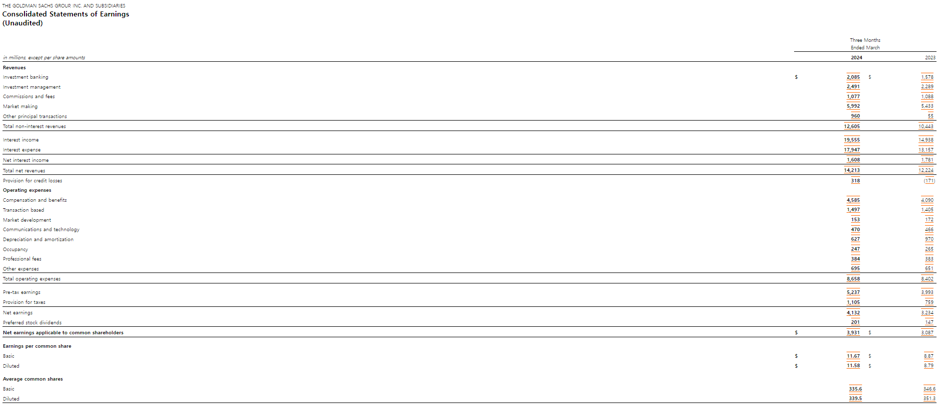

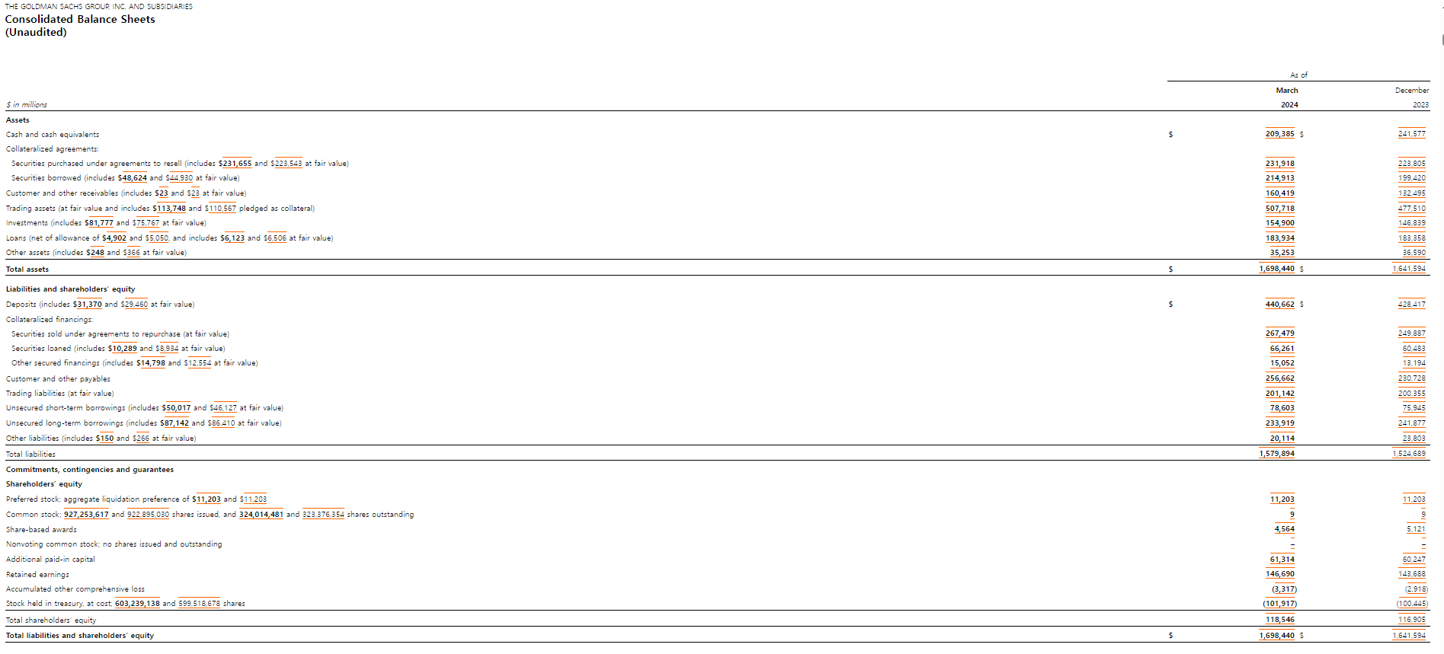

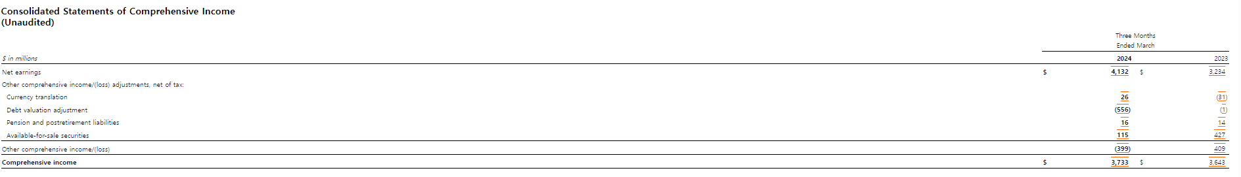

2024 10-q Net revenues

Earning per share Price-earning ratio

10-q

10-k 4132 /118546=0.03

Price=93.90

EPS=2.04(Basic) 2.02(Dilluted)

PER=46

ROE 266/100140=0.03

Morgan Stanley

